D2L - Combine multiple course sections together in D2L
Official URL: https://services.smsu.edu/TDClient/180/Portal/KB/Article/3608/D2L-Combine-multiple-course-sections-together-in-D2L
Category: Knowledge Base > Information Technology Services > Teaching and Learning (COLT) > D2L - Combine multiple course sections together in D2L
Tags: faculty, d2l, CourseCombine
_____________________________________________________

How to combine multiple course sections together in SMSU D2L Brightspace site
Faculty now have the ability to combine their courses in D2L Brightspace. All course merge requests (combining multiple course sections together) should be requested through the self-service
- Login into your SMSU D2L Brightspace account
- Click on Resources and then Course Self-Service in the upper left corner
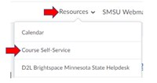
Figure 1: Uploaded Image (Thumbnail)
- If prompted to login to SharePoint, please do by using your starid@minnstate.edu and starid password
- Click on My Courses.
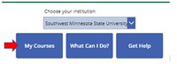
Figure 2: Uploaded Image (Thumbnail)
- In the advance search option, go ahead and filter by the semester

Figure 3: Uploaded Image (Thumbnail)
- Select the checkbox for each course section that you want to combine.
- Click Combine.
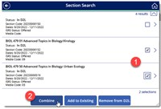
Figure 4: Uploaded Image (Thumbnail)
- Confirm the merged course details.
Note: The section listed first is the ‘base’ course. Any course materials in the base course will be copied automatically into the new, merged course. Click the pin icon to adjust.
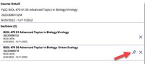
Figure 5: Uploaded Image (Thumbnail)
- Type the word merge into the confirmation field, and click Merge.The merge request has been submitted. An email will be sent when the request has been processed.
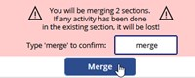
Figure 6: Uploaded Image (Thumbnail)
Accessibility Review & Update Log:
- [x] Content accuracy and link integrity verified
- [x] High-contrast visual hierarchy implemented (Inter and Calibri)
- [x] Image alt-text captions verified (all screenshots captioned)
- [x] PDF attachments scraped and fully inlined directly inside the document
- [x] Outline headers and standard list sequences optimized for screen readers

